0800 HOLY COMMUNION

THE SIXTH SUNDAY OF EASTER
Sunday 5 May 2024

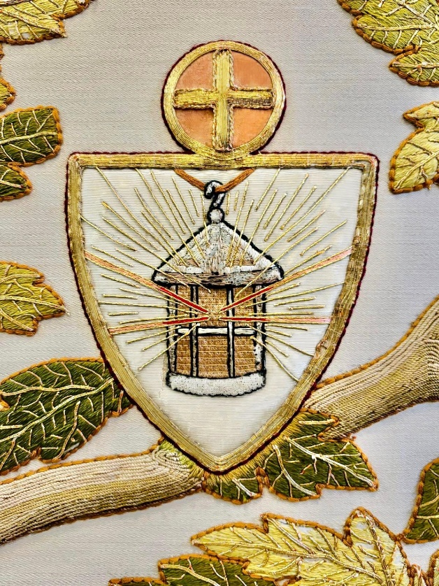

The Collect

God our redeemer,
who hast delivered us from the power of darkness
and brought us into the kingdom of thy Son:
grant, that as by his death he hath recalled us to life,
so by his continual presence in us he may raise us to eternal joy;
through Jesus Christ thy Son our Lord,
who liveth and reigneth with thee,
in the unity of the Holy Spirit,
one God, now and for ever.
All Amen.

Epistle
The Epistle is written in the tenth chapter of the Acts of the Apostles, beginning at the forty-fourth verse.

While Peter yet spake these words, the Holy Ghost fell on all them which heard the word. And they of the circumcision which believed were astonished, as many as came with Peter, because that on the Gentiles also was poured out the gift of the Holy Ghost.
For they heard them speak with tongues, and magnify God.
Then answered Peter, Can any man forbid water, that these should not be baptized, which have received the Holy Ghost as well as we?
And he commanded them to be baptized in the name of the Lord.
Then prayed they him to tarry certain days. (10.44-end)

Here endeth the Epistle.

Gospel

Priest The Holy Gospel is written in the fifteenth chapter of the Gospel according to Saint John beginning at the ninth verse.
All Glory be to thee, O Lord.

Jesus said: As the Father hath loved me, so have I loved you: continue ye in my love. If ye keep my commandments, ye shall abide in my love; even as I have kept my Father’s commandments, and abide in his love.
These things have I spoken unto you, that my joy might remain in you, and that your joy might be full.
This is my commandment, That ye love one another, as I have loved you.
Greater love hath no man than this, that a man lay down his life for his friends. Ye are my friends, if ye do whatsoever I command you.
Henceforth I call you not servants; for the servant knoweth not what his lord doeth: but I have called you friends; for all things that I have heard of my Father I have made known unto you.
Ye have not chosen me, but I have chosen you, and ordained you, that ye should go and bring forth fruit, and that your fruit should remain: that whatsoever ye shall ask of the Father in my name, he may give it you.
These things I command you, that ye love one another. (15. 9-17)

This is the Gospel of the Lord.
All Praise be to thee, O Christ.

Acknowledgements
Scripture readings: © 1989 National Council of the Churches of Christ, USA; Collect © The Archbishops’ Council 2000

0800 HOLY COMMUNION

THE SIXTH SUNDAY OF EASTER
Sunday 5 May 2024

The Collect

God our redeemer,
who hast delivered us from the power of darkness
and brought us into the kingdom of thy Son:
grant, that as by his death he hath recalled us to life,
so by his continual presence in us he may raise us to eternal joy;
through Jesus Christ thy Son our Lord,
who liveth and reigneth with thee,
in the unity of the Holy Spirit,
one God, now and for ever.
All Amen.

Epistle
The Epistle is written in the tenth chapter of the Acts of the Apostles, beginning at the forty-fourth verse.

While Peter yet spake these words, the Holy Ghost fell on all them which heard the word. And they of the circumcision which believed were astonished, as many as came with Peter, because that on the Gentiles also was poured out the gift of the Holy Ghost.
For they heard them speak with tongues, and magnify God.
Then answered Peter, Can any man forbid water, that these should not be baptized, which have received the Holy Ghost as well as we?
And he commanded them to be baptized in the name of the Lord.
Then prayed they him to tarry certain days. (10.44-end)

Here endeth the Epistle.

Gospel

Priest The Holy Gospel is written in the fifteenth chapter of the Gospel according to Saint John beginning at the ninth verse.
All Glory be to thee, O Lord.

Jesus said: As the Father hath loved me, so have I loved you: continue ye in my love. If ye keep my commandments, ye shall abide in my love; even as I have kept my Father’s commandments, and abide in his love.
These things have I spoken unto you, that my joy might remain in you, and that your joy might be full.
This is my commandment, That ye love one another, as I have loved you.
Greater love hath no man than this, that a man lay down his life for his friends. Ye are my friends, if ye do whatsoever I command you.
Henceforth I call you not servants; for the servant knoweth not what his lord doeth: but I have called you friends; for all things that I have heard of my Father I have made known unto you.
Ye have not chosen me, but I have chosen you, and ordained you, that ye should go and bring forth fruit, and that your fruit should remain: that whatsoever ye shall ask of the Father in my name, he may give it you.
These things I command you, that ye love one another. (15. 9-17)

This is the Gospel of the Lord.
All Praise be to thee, O Christ.

Acknowledgements
Scripture readings: © 1989 National Council of the Churches of Christ, USA; Collect © The Archbishops’ Council 2000

