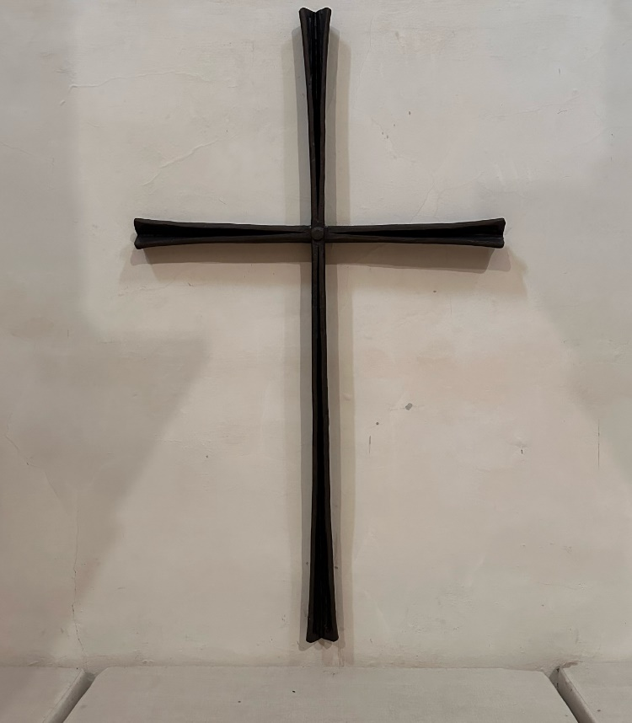

# The Liturgy of the Passion

**Good Friday**

**1400**

The Gathering

Please kneel or remain seated as the Choir and ministers enter in silence

and kneel in the desolate sanctuary.

After a time of silent prayer, the Collect is said.

## The Collect

Almighty Father,

look with mercy on this your family

for which our Lord Jesus Christ

was content to be betrayed

and given up into the hands of sinners

and to suffer death upon the cross;

who is alive and glorified

with you and the Holy Spirit,

one God, now and for ever.

*All* **Amen.**

*All sit.*

# The Liturgy of the Word

## Old Testament Reading

A reading from the book of the prophet Isaiah.

See, my servant shall prosper; he shall be exalted and lifted up, and shall be very high. Just as there were many who were astonished at him – so marred was his appearance, beyond human semblance, and his form beyond that of mortals – so he shall startle many nations; kings shall shut their mouths because of him; for that which had not been told them they shall see, and that which they had not heard they shall contemplate. Who has believed what we have heard? And to whom has the arm of the Lord been revealed? For he grew up before him like a young plant, and like a root out of dry ground; he had no form or majesty that we should look at him, nothing in his appearance that we should desire him. He was despised and rejected by others; a man of suffering and acquainted with infirmity; and as one from whom others hide their faces he was despised, and we held him of no account.

Surely he has borne our infirmities and carried our diseases; yet we accounted him stricken, struck down by God, and afflicted. But he was wounded for our transgressions, crushed for our iniquities; upon him was the punishment that made us whole, and by his bruises we are healed. All we like sheep have gone astray; we have all turned to our own way, and the Lord has laid on him the iniquity of us all. He was oppressed, and he was afflicted, yet he did not open his mouth; like a lamb that is led to the slaughter, and like a sheep that before its shearers is silent, so he did not open his mouth. By a perversion of justice he was taken away. Who could have imagined his future? For he was cut off from the land of the living, stricken for the transgression of my people. They made his grave with the wicked and his tomb with the rich, although he had done no violence, and there was no deceit in his mouth. Yet it was the will of the Lord to crush him with pain. When you make his life an offering for sin, he shall see his offspring, and shall prolong his days; through him the will of the Lord shall prosper.

Out of his anguish he shall see light; he shall find satisfaction through his knowledge. The righteous one, my servant, shall make many righteous, and he shall bear their iniquities. Therefore I will allot him a portion with the great, and he shall divide the spoil with the strong; because he poured out himself to death, and was numbered with the transgressors; yet he bore the sin of many, and made intercession for the transgressors.

*(52.13-53.12)*

At the end:

We adore you, O Christ, and we bless you.

*All* By your holy cross you have redeemed the world.

Remain seated while the Cathedral Choir sings.

## O vos omnes qui transitis per viam,

## attendite et videte si est dolor similis sicut dolor meus.

## Attendite, universi populi, et videte dolorem meum:

## si est dolor similis sicut dolor meus.

## *O all you who pass by on the road,*

## *attend and see if there be any sorrow like my sorrow.*

## *Attend, all you people, and see my sorrow -*

## *if there be any sorrow like my sorrow.*

## *Words: Tenebrae Responsory based on Lamentations 1.12*

## *Music: Giovanni Croce (1557-1609)*

## New Testament Reading

A reading from the Letter to the Hebrews.

Since, then, we have a great high priest who has passed through the heavens, Jesus, the Son of God, let us hold fast to our confession. For we do not have a high priest who is unable to sympathize with our weaknesses, but we have one who in every respect has been tested as we are, yet without sin. Let us therefore approach the throne of grace with boldness, so that we may receive mercy and find grace to help in time of need. In the days of his flesh, Jesus offered up prayers and supplications, with loud cries and tears, to the one who was able to save him from death, and he was heard because of his reverent submission. Although he was a Son, he learned obedience through what he suffered; and having been made perfect, he became the source of eternal salvation for all who obey him.

*(4.14-16, 5.7-9)*

At the end:

We adore you, O Christ, and we bless you.

*All* By your holy cross you have redeemed the world.

Silence is kept.

## The Passion

## 

Those who are able to are invited to stand for the whole of the Passion Gospel. Otherwise please remain seated at the start and stand at the moment Jesus is condemned to death.

The Passion of our Lord Jesus Christ according to John.

After Jesus had spoken these words, he went out with his disciples across the Kidron valley to a place where there was a garden, which he and his disciples entered. Now Judas, who betrayed him, also knew the place, because Jesus often met there with his disciples. So Judas brought a detachment of soldiers together with police from the chief priests and the Pharisees, and they came there with lanterns and torches and weapons.

Then Jesus, knowing all that was to happen to him, came forward and asked them, ‘For whom are you looking?’ They answered, ‘Jesus of Nazareth.’

Jesus replied, ‘I am he.’ Judas, who betrayed him, was standing with them.

When Jesus said to them, ‘I am he’, they stepped back and fell to the ground. Again he asked them, ‘For whom are you looking?’ And they said, ‘Jesus of Nazareth.’ Jesus answered, ‘I told you that I am he. So if you are looking for me, let these men go.’ This was to fulfil the word that he had spoken, ‘I did not lose a single one of those whom you gave me.’ Then Simon Peter, who had a sword, drew it, struck the high priest’s slave, and cut off his right ear. The slave’s name was Malchus. Jesus said to Peter, ‘Put your sword back into its sheath. Am I not to drink the cup that the Father has given me?’

So the soldiers, their officer, and the Jewish police arrested Jesus and bound him. First they took him to Annas, who was the father-in-law of Caiaphas, the high priest that year. Caiaphas was the one who had advised the Jews that it was better to have one person die for the people. Simon Peter and another disciple followed Jesus. Since that disciple was known to the high priest, he went with Jesus into the courtyard of the high priest, but Peter was standing outside at the gate. So the other disciple, who was known to the high priest, went out, spoke to the woman who guarded the gate, and brought Peter in. The woman said to Peter, ‘You are not also one of this man’s disciples, are you?’ He said, ‘I am not.’ Now the slaves and the police had made a charcoal fire because it was cold, and they were standing round it and warming themselves. Peter also was standing with them and warming himself.

Then the high priest questioned Jesus about his disciples and about his teaching. Jesus answered, ‘I have spoken openly to the world; I have always taught in synagogues and in the temple, where all the Jews come together. I have said nothing in secret. Why do you ask me? Ask those who heard what I said to them; they know what I said.’ When he had said this, one of the police standing nearby struck Jesus on the face, saying, ‘Is that how you answer the high priest?’ Jesus answered, ‘If I have spoken wrongly, testify to the wrong. But if I have spoken rightly, why do you strike me?’ Then Annas sent him bound to Caiaphas the high priest.

Now Simon Peter was standing and warming himself. They asked him, ‘You are not also one of his disciples, are you?’ He denied it and said, ‘I am not.’ One of the slaves of the high priest, a relative of the man whose ear Peter had cut off, asked, ‘Did I not see you in the garden with him?’ Again Peter denied it, and at that moment the cock crowed.

Then they took Jesus from Caiaphas to Pilate’s headquarters. It was early in the morning. They themselves did not enter the headquarters, so as to avoid ritual defilement and to be able to eat the Passover. So Pilate went out to them and said, ‘What accusation do you bring against this man?’

They answered, ‘If this man were not a criminal, we would not have handed him over to you.’ Pilate said to them, ‘Take him yourselves and judge him according to your law.’ The Jews replied, ‘We are not permitted to put anyone to death.’ (This was to fulfil what Jesus had said when he indicated the kind of death he was to die.)

Then Pilate entered the headquarters again, summoned Jesus, and asked him, ‘Are you the King of the Jews?’ Jesus answered, ‘Do you ask this on your own, or did others tell you about me?’ Pilate replied, ‘I am not a Jew, am I? Your own nation and the chief priests have handed you over to me. What have you done?’ Jesus answered, ‘My kingdom is not from this world. If my kingdom were from this world, my followers would be fighting to keep me from being handed over to the Jews. But as it is, my kingdom is not from here.’ Pilate asked him, ‘So you are a king?’ Jesus answered, ‘You say that I am a king. For this I was born, and for this I came into the world, to testify to the truth. Everyone who belongs to the truth listens to my voice.’ Pilate asked him, ‘What is truth?’

After he had said this, he went out to the Jews again and told them, ‘I find no case against him. But you have a custom that I release someone for you at the Passover. Do you want me to release for you the King of the Jews?’ They shouted in reply, ‘Not this man, but Barabbas!’ Now Barabbas was a bandit. Then Pilate took Jesus and had him flogged. And the soldiers wove a crown of thorns and put it on his head, and they dressed him in a purple robe. They kept coming up to him, saying, ‘Hail, King of the Jews!’ and striking him on the face. Pilate went out again and said to them, ‘Look, I am bringing him out to you to let you know that I find no case against him.’ So Jesus came out, wearing the crown of thorns and the purple robe. Pilate said to them, ‘Here is the man!’ When the chief priests and the police saw him, they shouted, ‘Crucify him! Crucify him!’ Pilate said to them, ‘Take him yourselves and crucify him; I find no case against him.’ The Jews answered him, ‘We have a law, and according to that law he ought to die because he has claimed to be the Son of God.’ Now when Pilate heard this, he was more afraid than ever. He entered his headquarters again and asked Jesus, ‘Where are you from?’ But Jesus gave him no answer. Pilate therefore said to him, ‘Do you refuse to speak to me? Do you not know that I have power to release you, and power to crucify you?’ Jesus answered him, ‘You would have no power over me unless it had been given you from above; therefore the one who handed me over to you is guilty of a greater sin.’ From then on Pilate tried to release him, but the Jews cried out, ‘If you release this man, you are no friend of the emperor. Everyone who claims to be a king sets himself against the emperor.’

*Please stand at this point, if you are able to.*

When Pilate heard these words, he brought Jesus outside and sat on the judge’s bench at a place called The Stone Pavement, or in Hebrew Gabbatha. Now it was the day of Preparation for the Passover; and it was about noon. He said to the Jews, ‘Here is your King!’ They cried out, ‘Away with him! Away with him! Crucify him!’ Pilate asked them, ‘Shall I crucify your King?’ The chief priests answered, ‘We have no king but the emperor.’ Then he handed him over to them to be crucified.

So they took Jesus; and carrying the cross by himself, he went out to what is called The Place of the Skull, which in Hebrew is called Golgotha. There they crucified him, and with him two others, one on either side, with Jesus between them. Pilate also had an inscription written and put on the cross. It read, ‘Jesus of Nazareth, the King of the Jews.’ Many of the Jews read this inscription, because the place where Jesus was crucified was near the city; and it was written in Hebrew, in Latin, and in Greek. Then the chief priests of the Jews said to Pilate, ‘Do not write, “The King of the Jews”, but, “This man said, I am King of the Jews.” ’ Pilate answered, ‘What I have written I have written.’ When the soldiers had crucified Jesus, they took his clothes and divided them into four parts, one for each soldier. They also took his tunic; now the tunic was seamless, woven in one piece from the top. So they said to one another, ‘Let us not tear it, but cast lots for it to see who will get it.’ This was to fulfil what the scripture says, ‘They divided my clothes among themselves, and for my clothing they cast lots.’ And that is what the soldiers did.

Meanwhile, standing near the cross of Jesus were his mother, and his mother’s sister, Mary the wife of Clopas, and Mary Magdalen. When Jesus saw his mother and the disciple whom he loved standing beside her, he said to his mother, ‘Woman, here is your son.’ Then he said to the disciple, ‘Here is your mother.’ And from that hour the disciple took her into his own home. After this, when Jesus knew that all was now finished, he said (in order to fulfil the scripture), ‘I am thirsty.’ A jar full of sour wine was standing there. So they put a sponge full of the wine on a branch of hyssop and held it to his mouth. When Jesus had received the wine, he said, ‘It is finished.’ Then he bowed his head and gave up his spirit.

Since it was the day of Preparation, the Jews did not want the bodies left on the cross during the sabbath, especially because that sabbath was a day of great solemnity. So they asked Pilate to have the legs of the crucified men broken and the bodies removed. Then the soldiers came and broke the legs of the first and of the other who had been crucified with him.

But when they came to Jesus and saw that he was already dead, they did not break his legs. Instead, one of the soldiers pierced his side with a spear, and at once blood and water came out. (He who saw this has testified so that you also may believe. His testimony is true, and he knows[*](javascript:void(0);) that he tells the truth.) These things occurred so that the scripture might be fulfilled, ‘None of his bones shall be broken.’ And again another passage of scripture says, ‘They will look on the one whom they have pierced.’

*Text: John 18.1-19.37*

*Music: David Price (b.1969)*

Please kneel or sit. Silence is kept.

## The Prayers of Intercession

The prayers include periods of silence. The following response is used:

Lord, hear us.

*All* Lord, graciously hear us.

## The Proclamation of the Cross

During the hymn, please follow the Choir and clergy into the Nave.

This is the wood of the Cross,

on which hung the Saviour of the world.

*All* Come, let us worship.



*All sing.* Sing, my tongue, the glorious battle,

sing the ending of the fray,

o’er the Cross, the victor’s trophy,

sound the loud triumphant lay;

tell how Christ, the world’s Redeemer,

as a Victim won the day.

He endured the nails and spitting,  
 vinegar and spear and reed;  
 from his holy body piercèd  
 blood and water forth proceed:  
 earth and stars and sky and ocean  
 by that flood from stain are freed.

Bend thy boughs, O Tree of Glory,  
 thy too rigid sinews bend;  
 for awhile the ancient rigour,  
 that thy birth bestowed, suspend;  
 and the King on heavenly beauty  
 on thy bosom gently tend.  
  
 Thou alone wast counted worthy  
 this world's Ransom to sustain,  
 that a shipwrecked race for ever  
 might a port of refuge gain,  
 with the sacred Blood anointed  
 of the Lamb for sinners slain.

This is the wood of the Cross,

on which hung the Saviour of the world.

*All* Come, let us worship.

*When all are gathered around the cross, the hymn concludes.*

**Faithful Cross! above all other,**

one and only noble tree!

None in foliage, none in blossom,

none in fruit thy peer may be;

sweetest wood and sweetest iron,

sweetest weight is hung on thee.

*Words: Venantius Fortunatus (530-609)*

*Tune: PANGE LINGUA*

This is the wood of the Cross,

on which hung the Saviour of the world.

*All* Come, let us worship.

All are invited to come forward if they wish and touch the Cross or kneel before it for a moment in thanksgiving and devotion.

The Choir sings The Reproachesby John Sanders (1933-2003).

O my people, what have I done to you? How have I offended you? Answer me!  
I led you out of Egypt, from slavery to freedom,

but you led your Saviour to the cross.

Holy is God! Holy and strong! Holy immortal One, have mercy on us.

For forty years I led you safely through the desert.

I fed you with manna from heaven, and brought you to a land of plenty;

but you led your Saviour to the cross.

What more could I have done for you?

I planted you as my fairest vine, but you yielded only bitterness:

when I was thirsty you gave me vinegar to drink,

and you pierced your Saviour's side with a lance.

I opened the sea before you, but you opened my side with a spear.

I led you on your way in a pillar of cloud, but you led me to Pilate's court.

I bore you up with manna in the desert,

but you struck me down and scourged me.

I gave you saving water from the rock,

but you gave me gall and vinegar to drink.

I gave you a royal sceptre, but you gave me a crown of thorns.  
I raised you to the height of majesty, but you have raised me high on a cross.

At the end: O Saviour of the world,

who by your Cross and precious blood have redeemed us,

*All* save us and help us we humbly beseech you, O Lord.

# The Liturgy of the Sacrament

## The Lord’s Prayer

Standing at the foot of the Cross,

let us pray with confidence as our Saviour has taught us.

*All* Our Father, who art in heaven, hallowed be thy name;

thy kingdom come;

thy will be done; on earth as it is in heaven.

Give us this day our daily bread.

And forgive us our trespasses,

as we forgive those who trespass against us.

And lead us not into temptation;

but deliver us from evil.

For thine is the kingdom, the power and the glory,

for ever and ever. Amen.

*The Blessed Sacrament (consecrated last night at the Eucharist) is brought in silence to two ministers who stand at the foot of the Cross.*

Giving of Communion

Draw near with faith.

Receive the body of our Lord Jesus Christ which he gave for you.

Eat in remembrance that he died for you

and feed on him in your heart by faith with thanksgiving.

*All are invited to come forward and receive Holy Communion.*

*During the distribution of Communion the hymn is sung.*

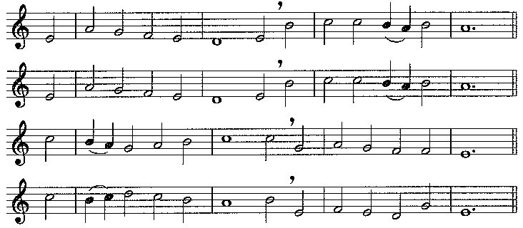

O sacred head, sore wounded,  
defiled and put to scorn;  
O kingly head surrounded  
with mocking crown of thorn:  
What sorrow mars thy grandeur?  
Can death thy bloom deflower?  
O countenance whose splendour

the hosts of heaven adore!

Thy beauty, long-desirèd,  
hath vanished from our sight;  
thy power is all expirèd,  
and quenched the light of light.  
Ah me! for whom thou diest,  
hide not so far thy grace:  
show me, O Love most highest,   
the brightness of thy face.

I pray thee, Jesus, own me,  
me, Shepherd good, for thine;  
who to thy fold hast won me,  
and fed with truth divine.  
Me guilty, me refuse not,  
incline thy face to me,  
this comfort that I lose not,  
on earth to comfort thee.

In thy most bitter passion  
my heart to share doth cry,  
with thee for my salvation  
upon the cross to die.  
Ah, keep my heart thus movèd  
to stand thy cross beneath,  
to mourn thee, well-beloved,  
yet thank thee for thy death.

My days are few, O fail not,  
with thine immortal power,  
to hold me that I quail not  
in death's most fearful hour;  
that I may fight befriended,  
and see in my last strife  
to me thine arms extended  
upon the cross of life.

*Words: P. Gerhardt (1607-1676) tr. R. Bridges*

#### Tune: PASSION CHORALE

*Once the Sacrament has been consumed, the candles are extinguished.*

*Silence is kept, and the service concludes with the final prayer.*

Most merciful God,

who by the death and resurrection of your Son Jesus Christ

delivered and saved the world:

grant that by faith in him who suffered on the cross

we may triumph in the power of his victory;

through Jesus Christ your Son our Lord,

who is alive and reigns with you, in the unity of the Holy Spirit,

one God, now and for ever. **Amen.**

*The ministers and people depart in silence.*